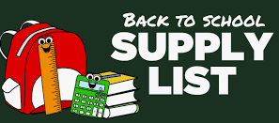

**Pre- Kindergarten**

4 boxes – Kleenex tissue

4 bottles – hand soap

2 boxes – washable markers

2 boxes – colored pencils

2 packs – thin dry erase markers

2 boxes – gallon Ziploc bags

**Kindergarten**

1 – one-inch binder with clear pocket on front

1 green plastic folders w/ prongs

1 blue plastic folders w/ prongs

2 pack – clear sheet protectors

1 backpack - NO wheels

1 school supply pencil box (plastic)

2 packs – pencils

2 packages – erasers

2 packs – dry erase markers

2 packs – 24 crayons

1 pack – Washable Markers

1 pair – child sized scissors

2 packs – 4 or more glue sticks

1 pack – assorted play-doh

2 boxes – Kleenex tissue

1 box – large and small Ziploc bags

**First Grade**

Backpack (No Wheels)

Headphones (No Earbuds)

5 – Folders (red, blue, green yellow and orange)

1 – Composition notebook

1 pair – Fiskar scissors

4 – Elmers glue sticks (large)

2 packs – pencils

2 boxes – Crayons (8ct. Only)

1 pack - index cards

1 pack – Post-it sticky notes

2 boxes – Kleenex tissue

1 Zippered pencil pouch

1 water bottle

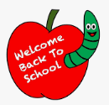

**Second Grade**

1 pack – glue sticks

1 pack- colored pencils

2 – Composition note books

1 – one inch binder with plastic cover

2 boxes - #2 pencils

1 box – Ziploc sandwich bags

1 box – Ziploc bags

1 box – Kleenex tissue

6 – Folders (2 pockets)

1 pack – wide-ruled paper

1 – Pencil box/pencil bag

1 pair of scissors

1 pack – dry erase markers

1 pack – cap eraser

1 pack - index cards

1 ruler

1 pair sturdy headphones

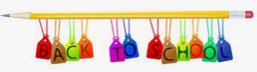

**Third Grade**

2 – Folders (2 pocket NO prongs)

1 boxes – Kleenex tissue

4 packs – Paper (wide-ruled)

1 - Pencil bag (3 holes for binder)

1 – Pack of clear package sleeve protectors

1 – Pack of dividers

2 – one inch 3-ring binder (clear view with inside pockets)

1 box – Ziploc bags (gallon and quart size)

2 – Composition notebooks

1 – Ruler

1 pack – Glue sticks

1 pair - scissors

1 pack – Multiplication Flash Cards

2 – Highlighters

2 packs - #2 Pencils

1 box – colored pencils

1 pack – 24 count crayons

1 pack – dry erase markers

1 pack – square sticky note pads

1 pack - index cards

2 pair – headphones/earbuds

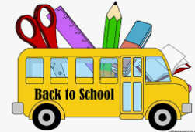

**Fourth Grade**

1 – 1 or 1 ½ inch binder

Dividers (5 tabs)

5 – Composition Notebooks

Protractor

2 packs - Paper (wide-rule)

1 – Pack of index cards

1 pack – colored pencils

1 pack – markers

1 pack - Crayons

2 boxes – wooden pencils

Erasers

Personal Pencil Sharpener

1 pack - Dry Erase Markers

1 pair of earbuds headphones

Water Bottle

**Fifth Grade**

1 – Backpack – NO wheels

4 – Composition books

4 packs – loose leaf paper

60 - #2 pencils

3 erasers or pencil top erasers

1 pack – colored pencils or crayons

1 pair of scissors

1 box – gallon size or quart size Ziploc bags

3 – Glue sticks

1 pair of earbuds headphones

5 – Plastic folders with pockets and prongs (any color)

3 boxes - Kleenex tissue

